PROJECT SUBMISSION

Project Name: Application Deployment

Step 1
Fork git into my git repo
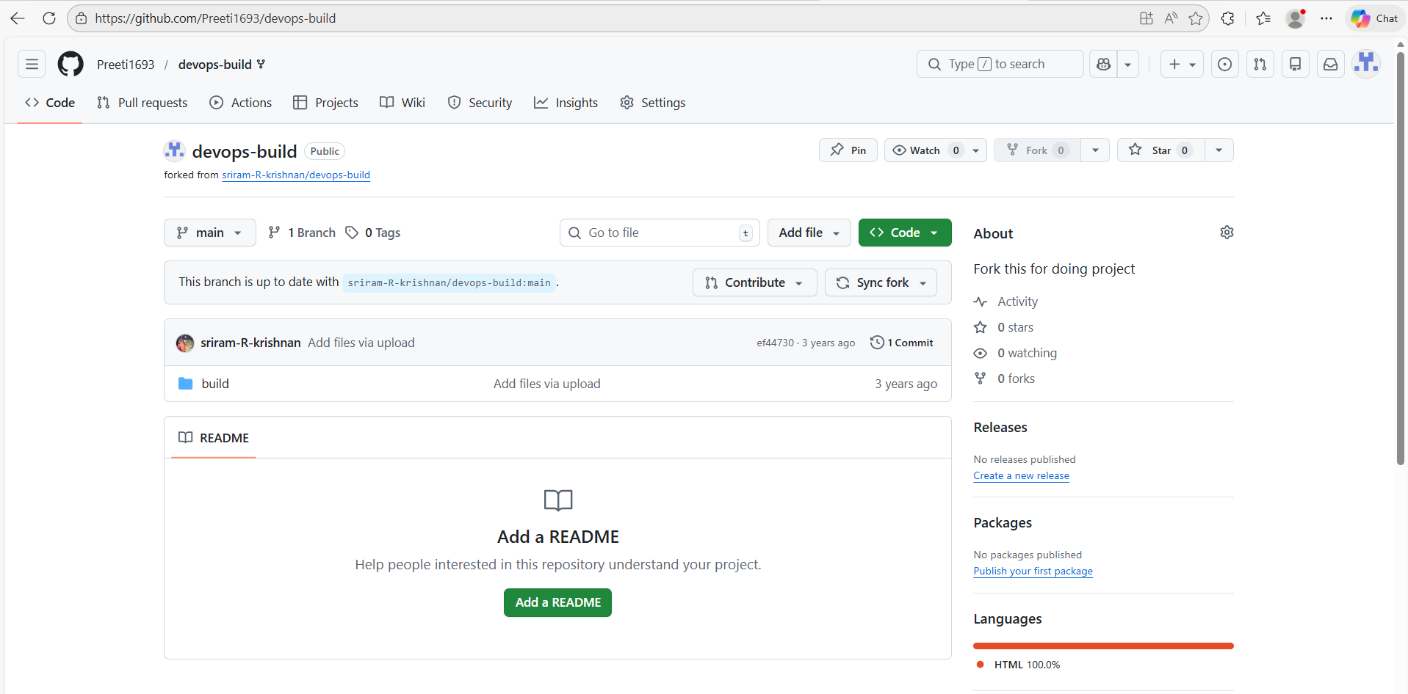

Step 2
local machine Setup (EC2)
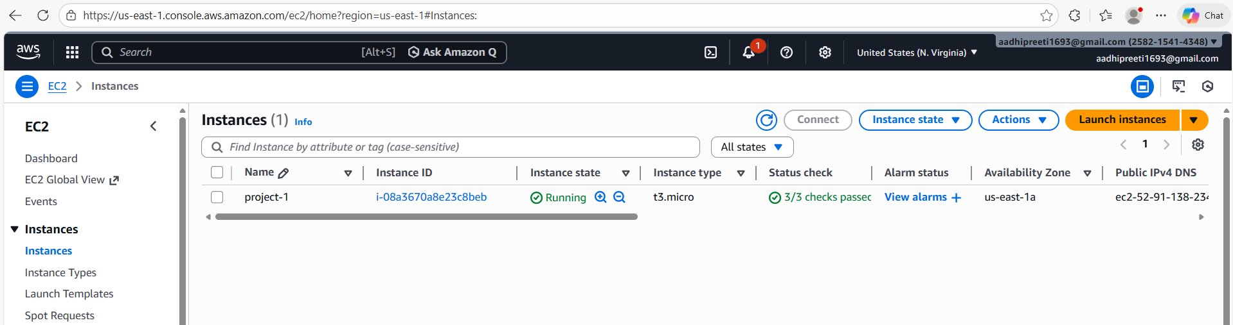

Security Group
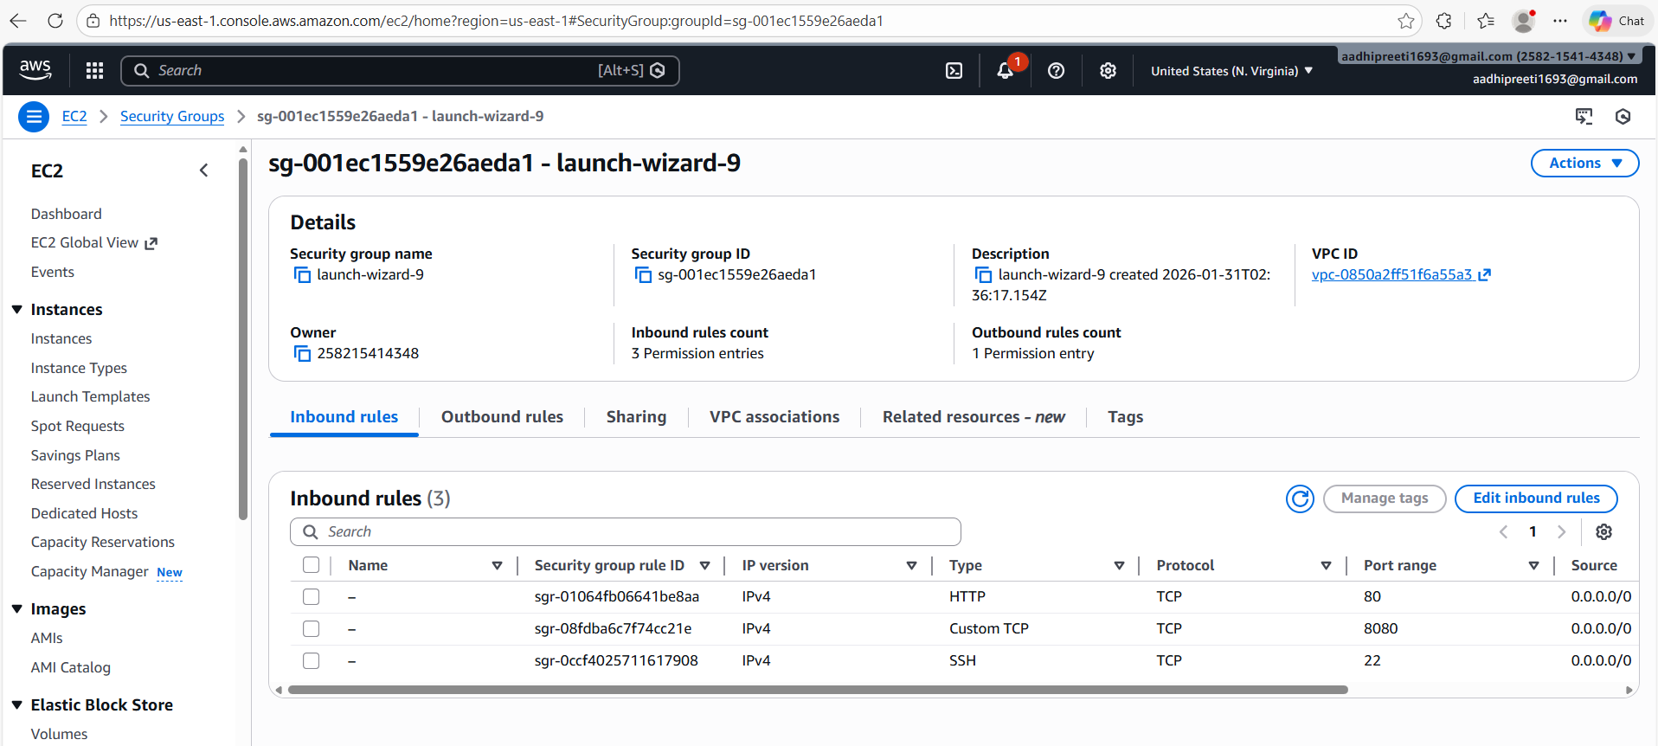

Step 3
DockerHub: dev and prod repo created
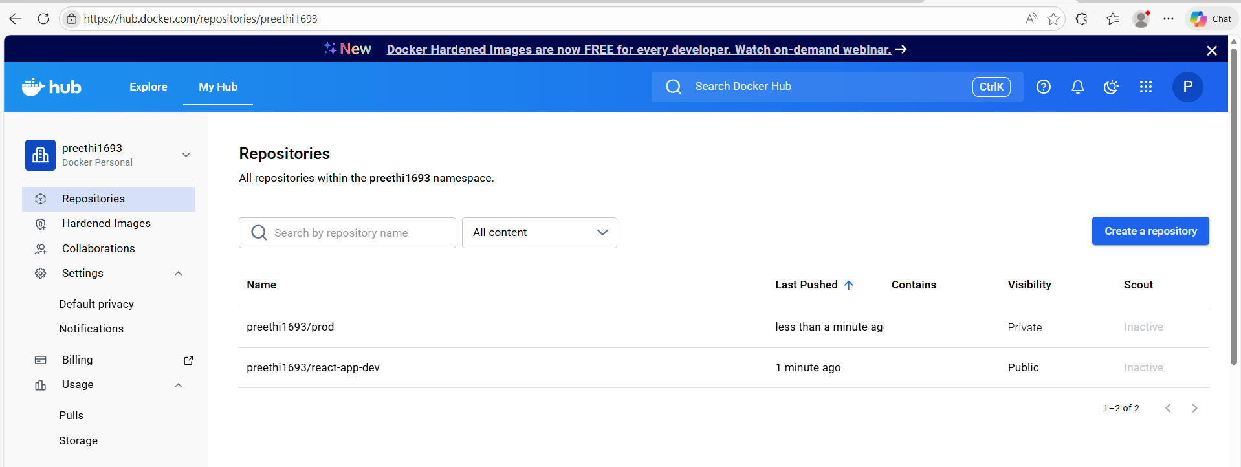

Step 4
Image pushed to dockerhub: Success
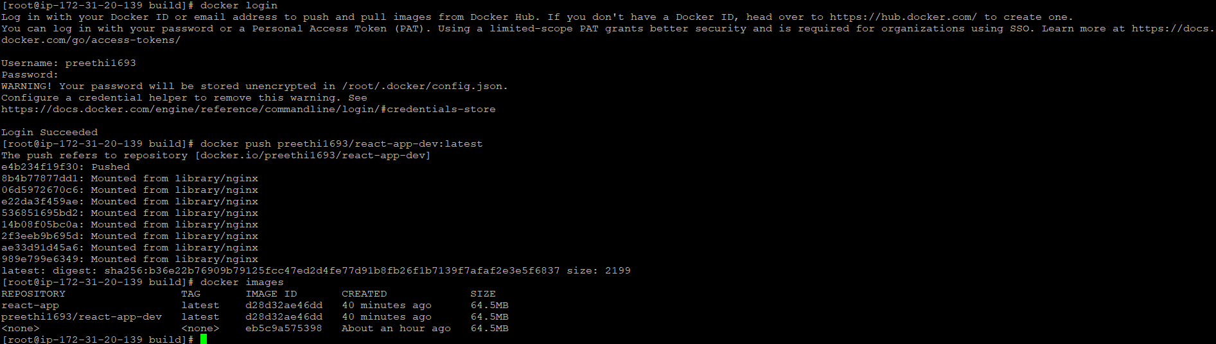
Step 5
Images shown in dockerhub: Artifact
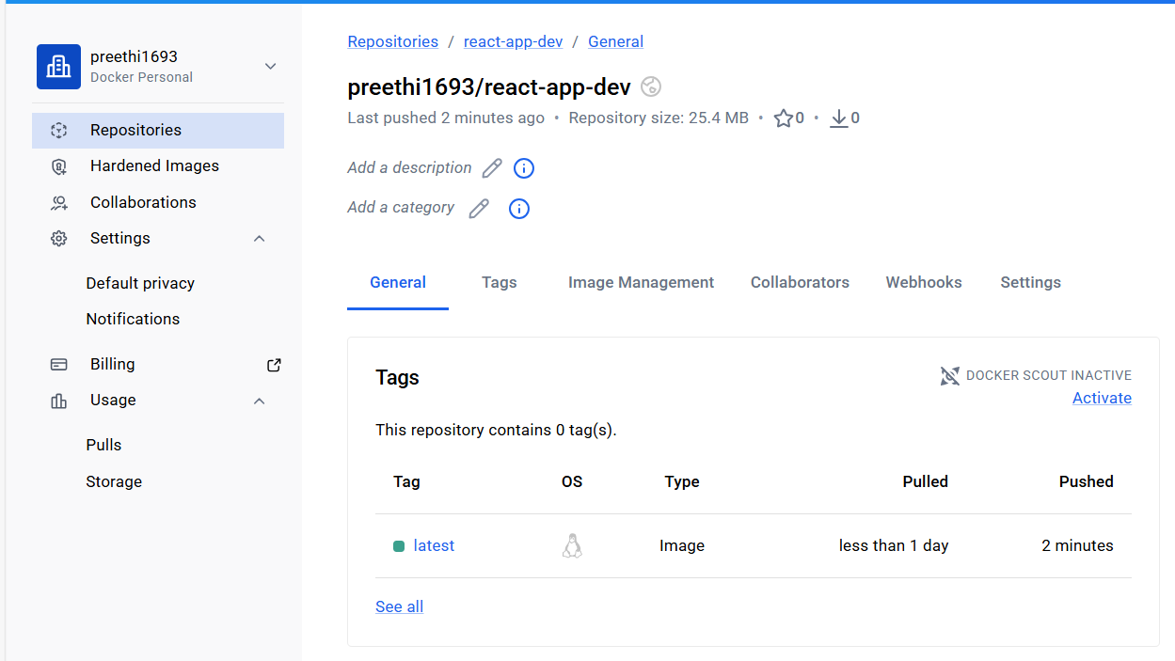

Step 6
Jenkins Home Page
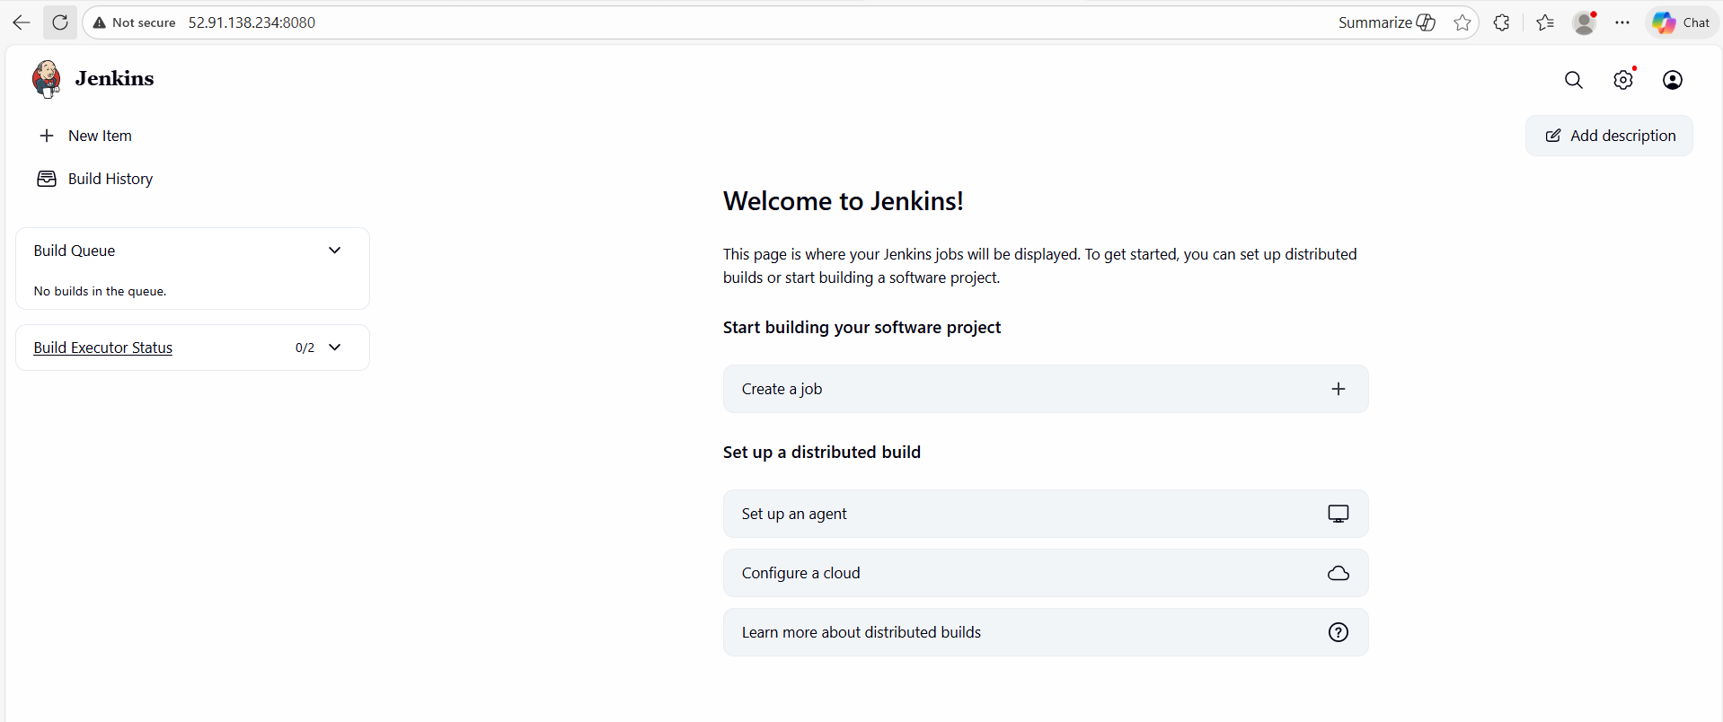

Step 7
Jenkins Pipeline setup
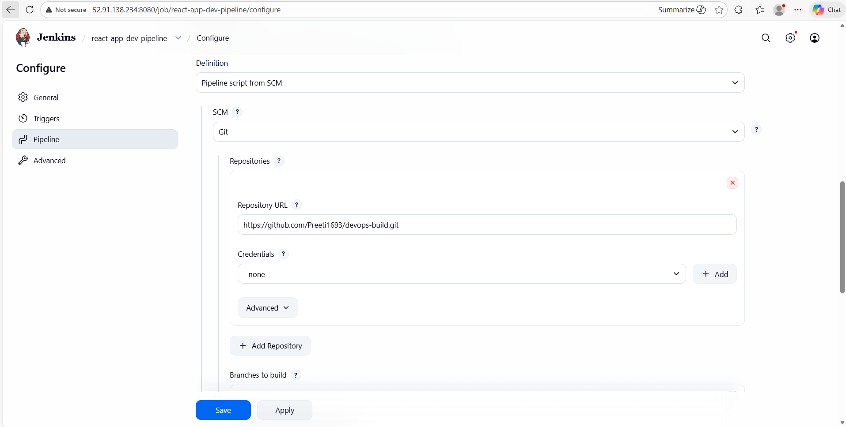

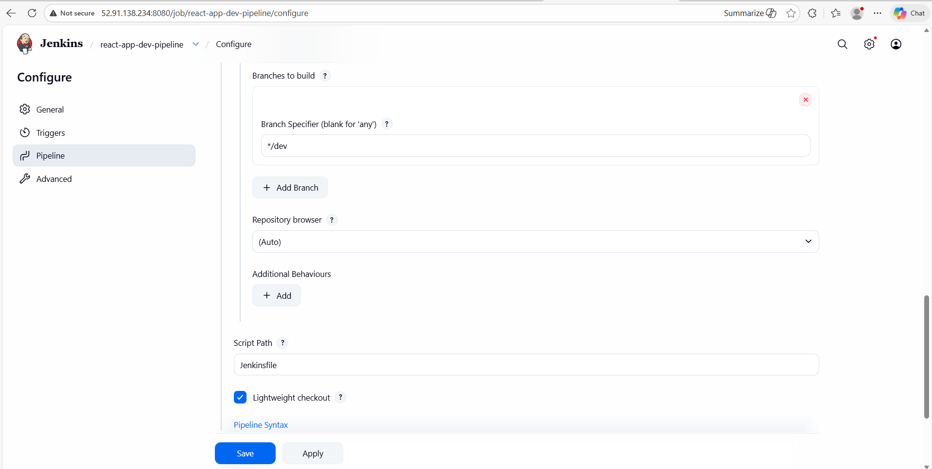

Step 8
Git Webhook setup
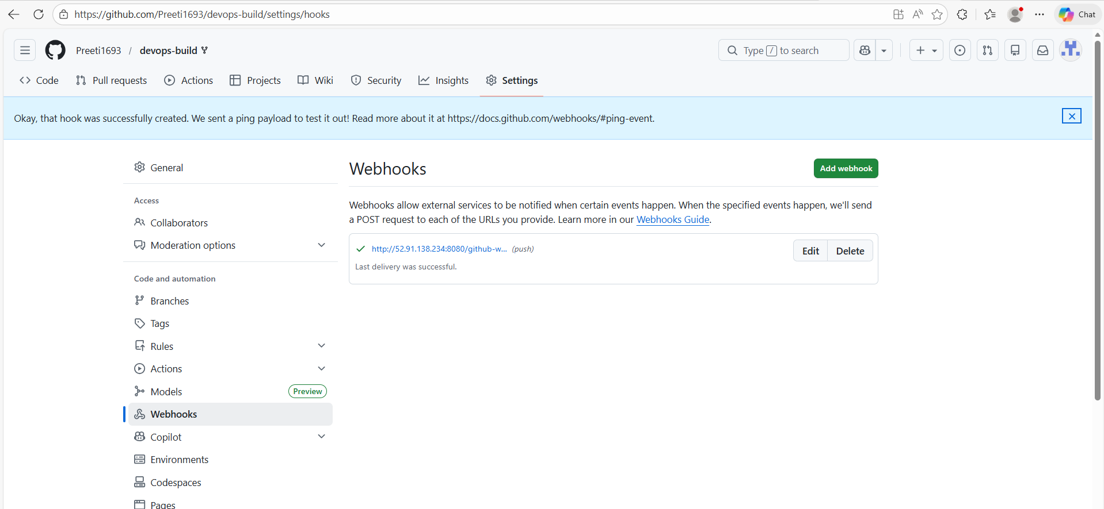

Step 9
Automatic deployment: Success
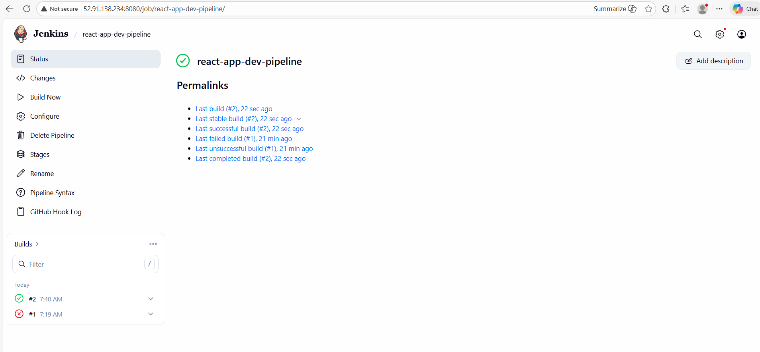

Step 10
Website
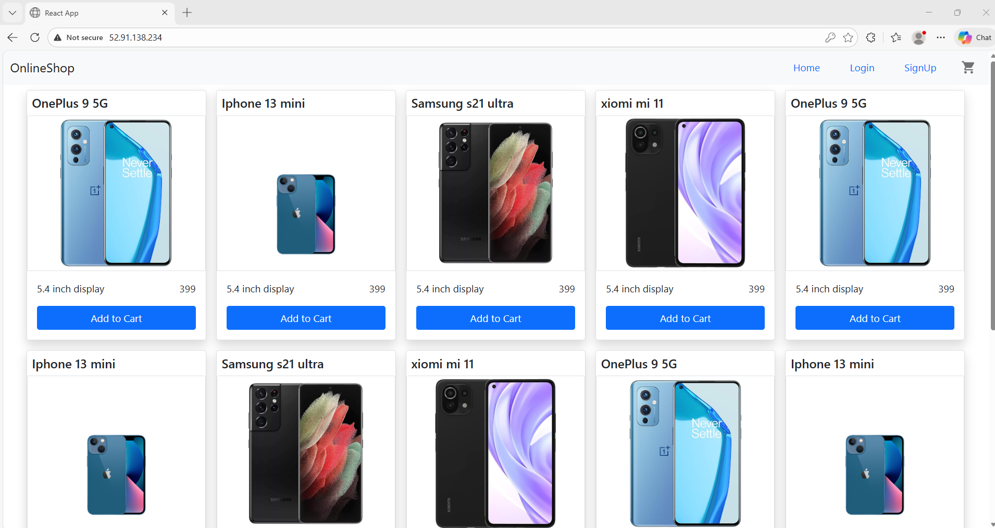

Step 11
Monitoring: Prometheus & Grafana
Node Exporter is installed in App server
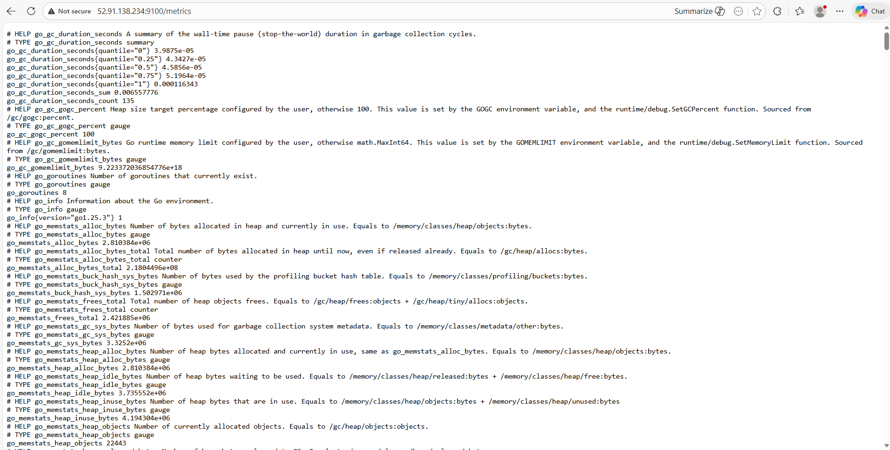

Step 12
Prometheus & Grafana installed: Success
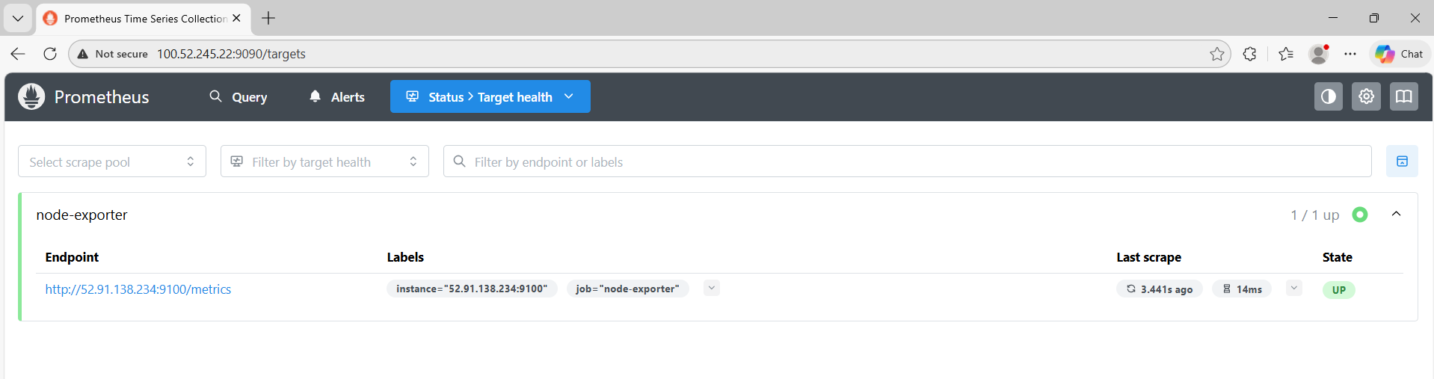
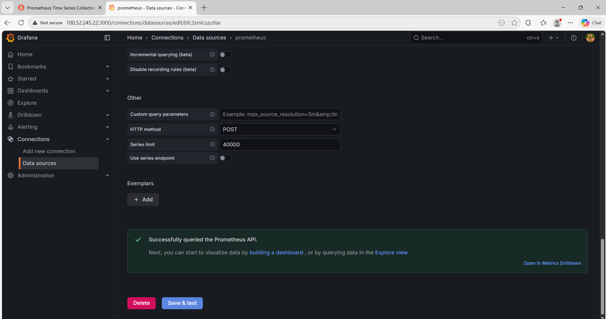

Step 13
Visualization
